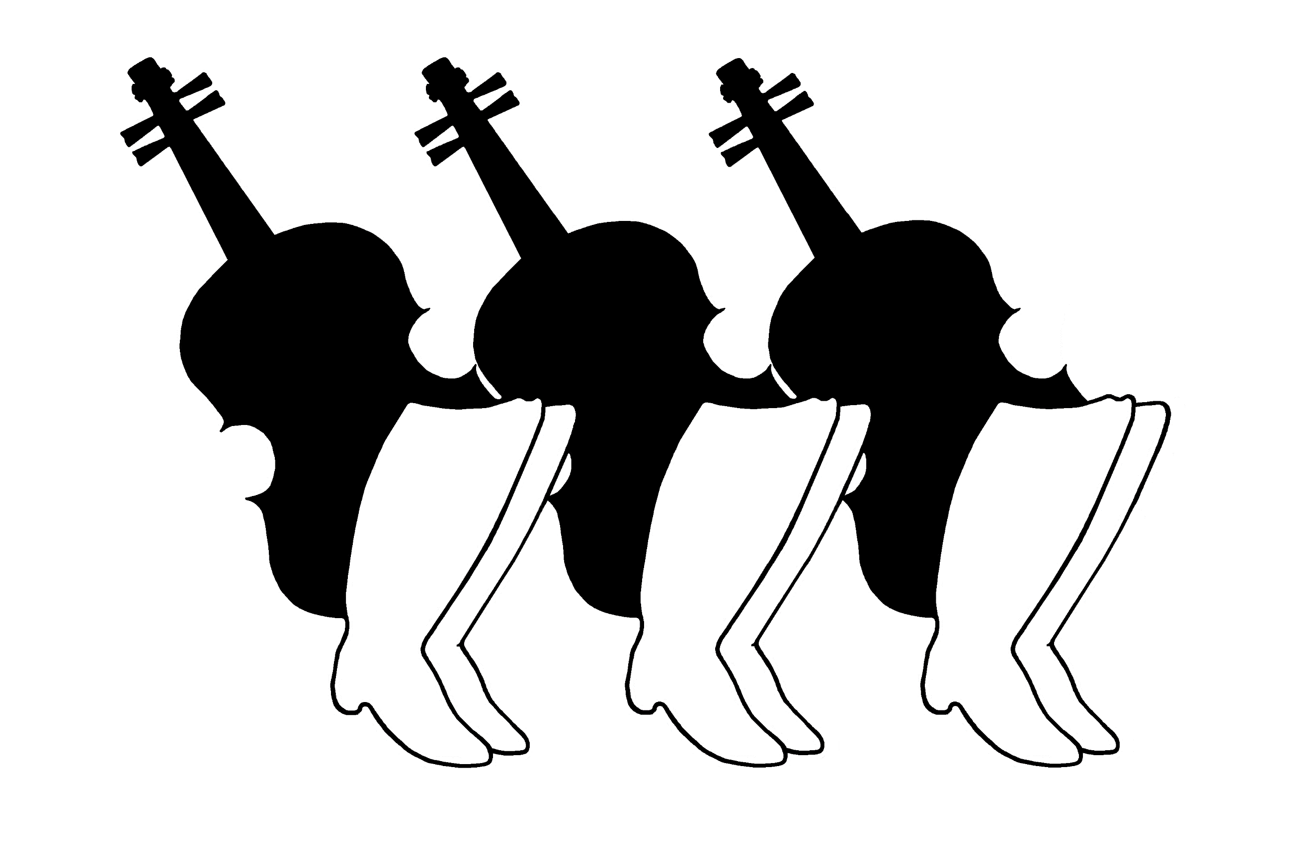
Ti Ti Tábor Hungarian Folk Camp
Registration Form 2020

Full Week Pricing August 2-9, 2020

Paid in Full before April 30th
$645 Program Participant
(lodging, food, lessons, táncház)
$520 Happy Camper (lodging, food, táncház)
$425 Teen (ages 13-17)
$295 Children (ages 6-12 years)
$125 Children (ages 3-5 years)
Paid in Full after April 30th
$695 Program Participant
(lodging, food, lessons, táncház)
$560 Happy Camper (lodging, food, táncház)
$475 Teen (ages 13-17)
$335 Children (ages 6-12 years)
$140 Children (ages 3-5 years

Special Request From Your Camp Organizers: We want to keep camp affordable and accessible to all! Please consider making a donation to help us continue to provide quality programming. We know that not everyone is able to donate and are grateful to those who can. You can also support camp by encouraging your friends to attend camp and spreading the word about our scholarships! We appreciate your support!

 | Participant 1 |  | Participant 2
Name:
Name as printed on nametag:
 | Male Female |  | Male Female
Address:
Street
City/State
Zip
Phone:
Email:
Program Choice(s): | Dance Singing Happy Camper  Instrument: __________________  Teen Children -age: _______ |  | Dance Singing Happy Camper  Instrument: __________________  Teen Children -age: _______
Accommodations: | Cabin Bringing Tent  I am making my own arrangement for a hotel |  | Cabin Bringing Tent  I am making my own arrangement for a hotel
Meal Plan: | Regular Vegetarian |  | Regular Vegetarian
Do you need transportation from the airport? | Yes No |  | Yes No
Make checks out to: Ti Ti Tábor Hungarian Folk Camp
$150 deposit per adult registration is required with registration.
Full payment must be postmarked by July 15, 2020.
Mail application to: Ti Ti Tábor, c/o Sue Isely, 22631 105th Ave. West, Edmonds, WA 98020
Refund policy: Full refund until May 31, 2020. After May 31, 2020, a cancellation fee of $85 per adult and teen registration applies. No Refunds after July 15, 2020.

