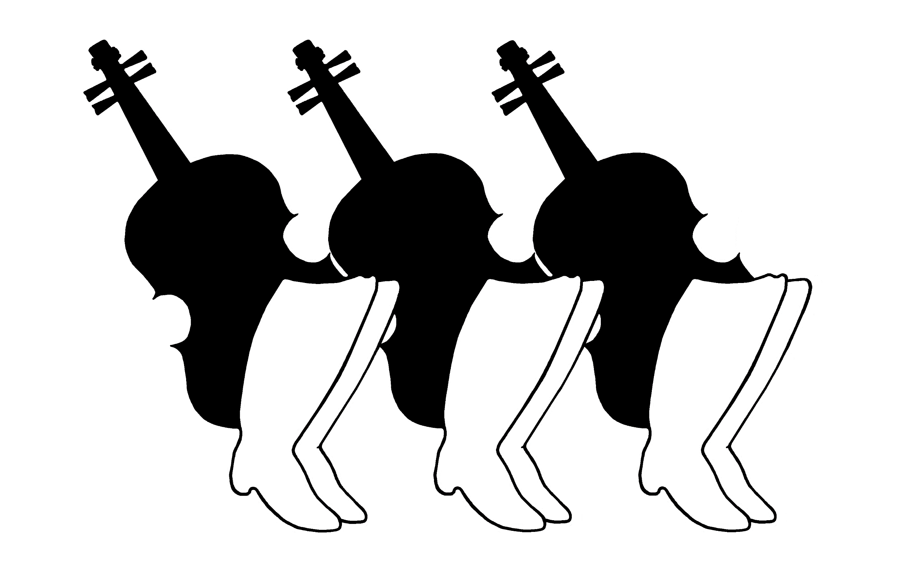
Ti Ti Tábor Hungarian Folk Camp
Registration Form 2018

Full Week Pricing - July 29-August 5, 2018

Paid in Full before April 30th
$645 Program Participant
(lodging, food, lessons, táncház)
$505 Happy Camper (lodging, food, táncház)
$425 Teen (ages 13-17)
$295 Children (ages 6-12 years)
$105 Children (ages 3-5 years)
Paid in Full after April 30th
$695 Program Participant
(lodging, food, lessons, táncház)
$555 Happy Camper (lodging, food, táncház)
$475 Teen (ages 13-17)
$335 Children (ages 6-12 years)
$125 Children (ages 3-5 years
Make checks out to: Ti Ti Tábor Hungarian Folk Camp
$150 deposit per adult registration is required with registration.
Full payment must be postmarked by July 15, 2017.
Mail application to: Ti Ti Tábor, c/o Sue Isely, 22631 105th Ave. West, Edmonds, WA 98020
Refund policy: Full refund until May 31, 2018. After May 31, 2018, a cancellation fee of $85 per adult and teen registration applies. No Refunds after July 15, 2018.

 | Participant 1 |  | Participant 2
Name:
Name as printed on nametag:
 | Male Female |  | Male Female
Address:
Street
City/State
Zip
Phone:
Email:
Program Choice(s): | Dance Singing Happy Camper  Instrument: __________________  Teen Children -age: _______ |  | Dance Singing Happy Camper  Instrument: __________________  Teen Children -age: _______
Accommodations: | Cabin Bringing Tent  I am making my own arrangement for a hotel |  | Cabin Bringing Tent  I am making my own arrangement for a hotel
Meal Plan: | Regular Vegetarian |  | Regular Vegetarian
Do you need transportation from the airport? | Yes No |  | Yes No

